What are the types of customers the company has and what is the count for each

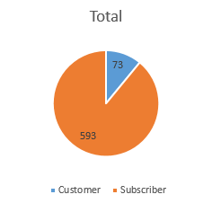

Bikeshare company has only two types of customers: Subscriber and customer. Subscriber consists of a total of 593 user IDs which is the package used by most of its users and 73 users use the Customer package.

*Figure 1: Count of customers and subscriber*

Do men make use of the service than women?

For the subscribe package, male makes use of it compared to the female

For the customer package, male makes use of it compared to the female

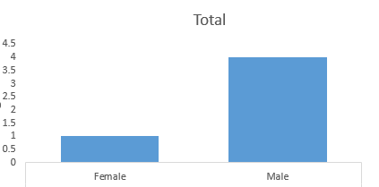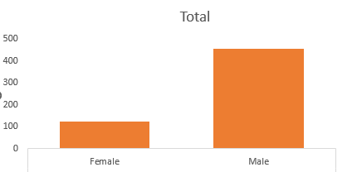

Figure 2: Customer Count for male and female

Figure 3: Subscriber count for both male and female

Generally, male makes use of bikeshare services compared to females so they should be targeted for most promo and advertisement

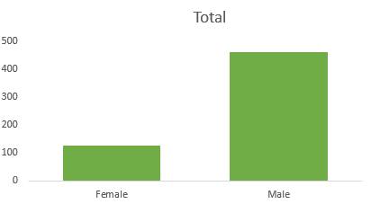

Figure : Total Count of users

What age group makes use of the bikeshare service the most

For the subscriber package, the hierarchy of use of this package is as follows: young, middle aged, elderly, old age. Since all age group makes use of the subscriber package so this package should be invested in more and be advertised everywhere

For the customer package, the young age group are the only age group that uses this package so a survey should be carried out to find out why is favored by the young population and the customer package should also be advertised to young people more.

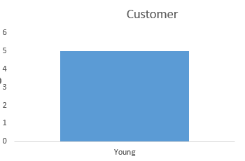 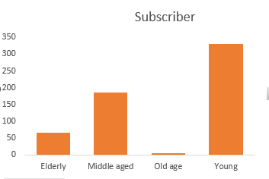

Figure 5: Age-group for customer users Figure 6: Age-group for subscriber users

Generally, more of the user consist of the young people which consists of 50.3% of the total users so this bikeshare service is being explored by young people

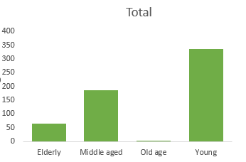

Figure 7: Age-group for users

What is the average trip duration

The age group with the highest average trip duration is the elderly which implies that elderly people use this service for more long-distance journey or the bike uses a low velocity when transporting elderly people

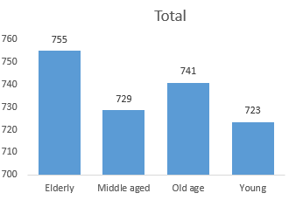

Figure 7: Average Trip duration for different age-groups

Users that use customer package, has a higher average trip duration compared to subscriber so more time-consuming journey should be specialized for customer package users and more discount be given to them

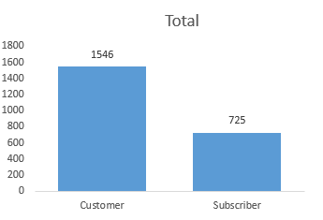

Figure 8: Average trip duration for different user types

Male has more average trip duration when compared to female

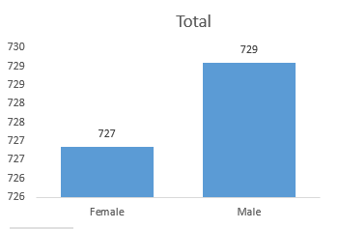

Figure 9: Average trip duration for male and female

The minimum trip duration is 75 and the optimal trip duration is 2226, the median is 587 and the 25th percentile is 347, the 75th percentile is 1098.75, the outlier here is 7386.

The average trip duration is 816.9 as indicated by the box plot so all bikes should last for an average time of 816.9 and a least time of 75 and an optimal value of 2226 this are a must lookout in the purchase of bike by bikeshare

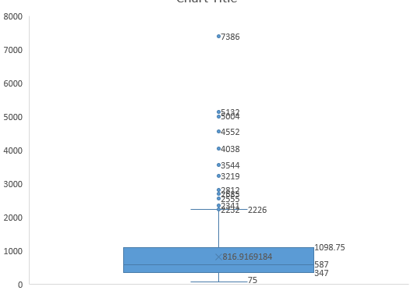

Figure 11: Box plot of trip duration showing the average as a \*

What is the age distribution of customers

Age distribution showing different showing different age groups and the number of users, the young population are the highest age group that uses bikeshare services and the old age are the age group that uses less of its services

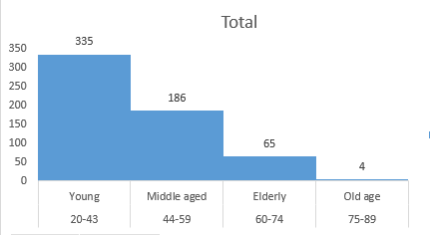

Figure : Age group Distribution showing different age group Classification

What day is the most busy

On Wednesdays, there’s rush hour and why is that so, so a survey should be conducted to find out why and more bikes should be dispatched on Wednesdays when compared to other days.

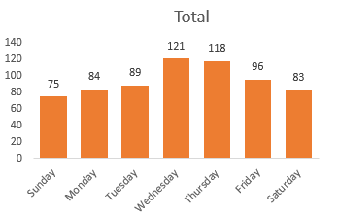

Figure : Most busy weekday

On Thursdays, more long trips are embarked on, so all bikes should be in good condition and ready for a long-distance travel

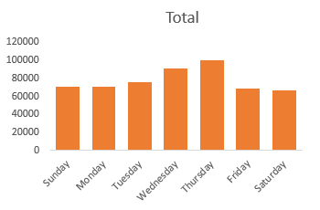

Figure : Weekday with the longest trip

Central Park S & 6 Ave is the most common start station and more resources and advertisement should be focused in this station and a survey should be carried out to find out why it is the most common start station.

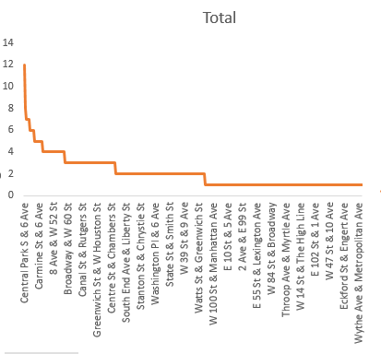

Figure : The most common start station

E17 St & Broadway was the most common end station used by many users so more resources should be focused on movement to this station.

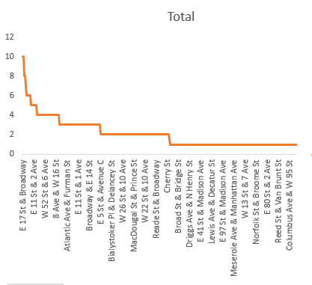

Figure : Most common end station

Old Fulton St to Old Fulton St is the trip data with the highest average trip duration, the distance between the trip should be calculated and also find out possible reasons for so and if there’s any other shorter route

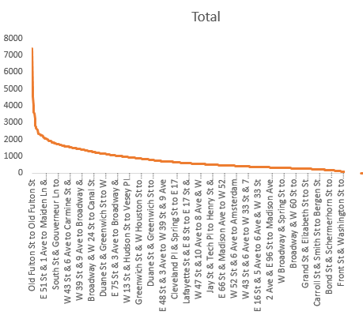

Figure : Average trip duration for different trip data

All users of Bikeshare services in this survey, only use their service once. So, a market survey should be carried out to find out why such happens and also an understanding whether it is the nature of the business.

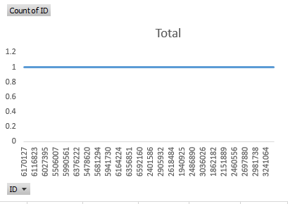

Figure : Number of times a user uses this service

Bikeshare company should make young male (male between 20-43) as their target market since it consists of 39.5% of the total user.

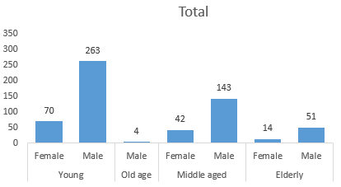

Figure : The target market